BILETO
Valid request
https://osdm-5.platform.bileto.zone/api/oauth/token
▼
Headers
(2)
> Accept:application/json
> content-type:application/x-www-form-urlencoded
Body
grant_type=client_credentials&client_id=xxxc2f&client_secret=xxx0a
Parameters used
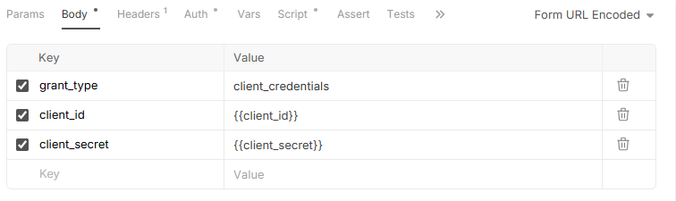
PAXONE
https://staging.sandbox.paxone.app/api/v1/auth/user/token
▼
Headers
(1)
> content-type:application/json
Body
{
"accountName": "pxxt",
"accountSecret": "oxxxxG7"
}
Parameters
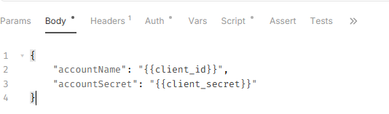
SQILLS
https://api.sqills-osdm-test.cloud.sqills.com/oauth/v2/token
▼
Headers
(2)
> Authorization:Basic NxxxxTI=
> content-type:application/json
Body
{
"grant_type": "https://com.sqills.s3.oauth.agent",
"username": "pxxx.xxxx.agent",
"password": "xxxxx"
}
Parameters used
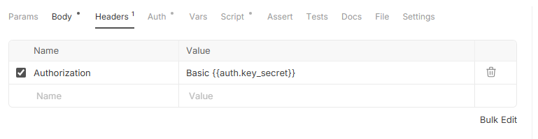
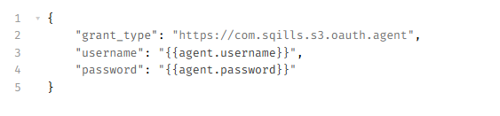
TURNIT
https://identity.sandbox.turnit.tech/connect/token
▼
Headers
(1)
> content-type:application/x-www-form-urlencoded
Body
grant_type=client_credentials&client_id=xxx-live&client_secret=xxxxxxca&scope=retailer-api

Parameters used :
